

**COMP3045 Information Visualization Project Coursework 2**

**Individual Report**

|  |  |
| --- | --- |
| **Name** | **Student ID** |
| Loh Jin Xian | 18816763 |

**Lecturer** **:** Dr. Marina Ng

1. **Individual Contribution and Reflection**

The whole process of creating coursework 2.0 has been a long and unforgetful journey. Starting from learning the basic of data visualization framework like D3.js to the creation of infographics that reflect the information extracted from the dataset. Other than that, the coursework taught us a valuable lesson which is teamwork and how supportive team members can motivate each other to achieve more despite the stress and sleepless nights that we had after the submission of our final year project. Regardless, all of us pushed through it and achieved the impossible. One important factor that enable us to work together is the willingness to listen to opinions and ideas with an open mind. We would discuss and find the best solution that will benefits the whole team instead of personal gains. I am very thankful for all my team members as they always lend a hand when I need it the most and they raised the bar by putting more effort in creating great infographics.

As for individual contribution, I first set the theme of the infographic and organize how the dataset should be presented in terms of both poster and D3.js. Initially, we wanted to show the infographic in a comic book format, where different tiles in the comic book is a new dataset. After some prototyping, we realized that the idea is not as practical, so we ended up with website design format, where different infographics are shown in tiles in the website. We also focused a lot on the narratives of the infographic, thinking of ways to create a story that is easily understood by the public on how fats, calories intake, and lack of exercises are causes of obesity in this day and age.

Then, different tasks are divided to different team members to ensure an effective and efficient implementation process. In terms of the D3.js project, I was in charged of creating the bar chart that compare the fats and calories intake of Malaysians with other countries as seen in figure 1.0.

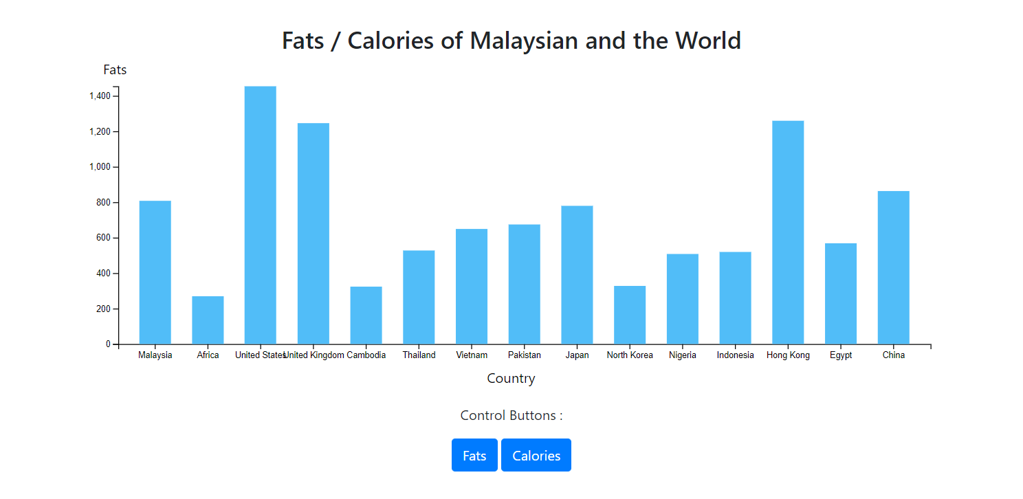

***Figure 1.0*** *Bar chart that compares fats and calories intake between Malaysian and the world*

At the same time, overlooked the process of others creating a variety of infographics to determine which goes well with which infographic. Once all infographics are created, I made sure that they were placed in the website properly with clearly defined grid and empty spaces. Last but not least, I read and correct any mistakes made in the group report before it was sent in to Moodle.